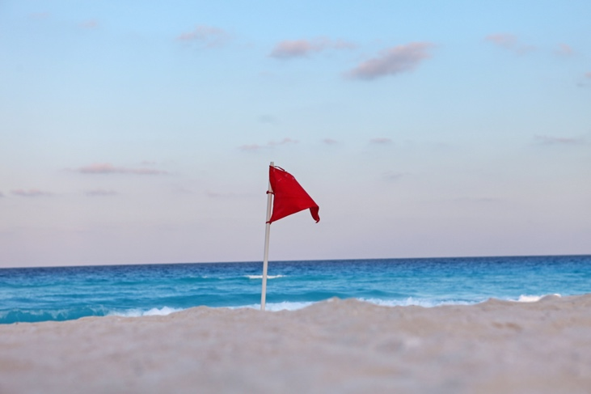 2022 FMMGA CHALLENGE 

PLEASE READ DIRECTIONS FOR EACH HOLE.

FAILURE TO PLAY HOLE AS DESCRIBED BELOW WILL RESULT IN FORFIET OF THE HOLE AND MAX SCORE

All players tee off between **RED FLAGS**. Please hole out all putts.

We will roll the ball everywhere one club length unless in hazard.

MAX HOLE SCORE IS DOUBLE PAR

**\*\*\*\*PLEASE KEEP UP WITH THE GROUP IN FRONT OF YOU\*\*\*\***

HOLE 1: Left of blue tees and left of cart path. This is a challenge, not a walk in the park…Good luck.

HOLE 2: Near tree just to the right of cart path about 185 yards out from middle of green. Still par 4.

HOLE 3: Back across bridge just in front of cart path. About 165 yards from middle of green.

HOLE 4: Right of cart path across from blue tee.

HOLE 5: Just behind red tee box. Uphill lie about 155 yards from middle of green.

HOLE 6: Just in front of white tees on the right side of the cart path near bushes.

HOLE 7: Behind blue tee box near cart parking, way back.

HOLE 8: On #6 white tee box. Please be cautious of #7 green activities.

HOLE 9: About 30 yards in front of red tee box to the right of the cart path in the trees.

HOLE 10: Behind blue tee box near cart path and bench. About 170 yards to middle of green.

HOLE 11: Between white and gold tee box on left side.

HOLE 12: Behind 11 green. Please be cautious of #11 green activities.

HOLE 13: About 30 yards in front of red tee box on left side of cart path in trees.

HOLE 14: Between white and blue tee box.

HOLE 15: ***YOU MAY ONLY USE A 7 IRON AND A 9 IRON ON THIS HOLE…NO OTHER CLUBS ALLOWED ON THIS HOLE*** Tee box is to the right of gold tees.

HOLE 16: On #13 tee box.

HOLE 17: In trees behind WAY behind white tee box almost even with back of blue tee box. Hee Hee.

HOLE 18: Behind blue tees and cart path. Yeah, long but you are almost done.